**Module 1 Activity 1: Installation of Tools (Integrated Development Environment)**

Anudeep Anisetty

Information Technology, Arizona State University

IFT 554: Middleware Prog & Database Sec

Dinesh Sthapit

January 21, 2024

**Module 1 Activity 1: Installation of Tools (Integrated Development Environment)**

1. **Visual Studio Code Installation Proof:**

*Screenshot of the Visual Studio Code application running on your desktop*

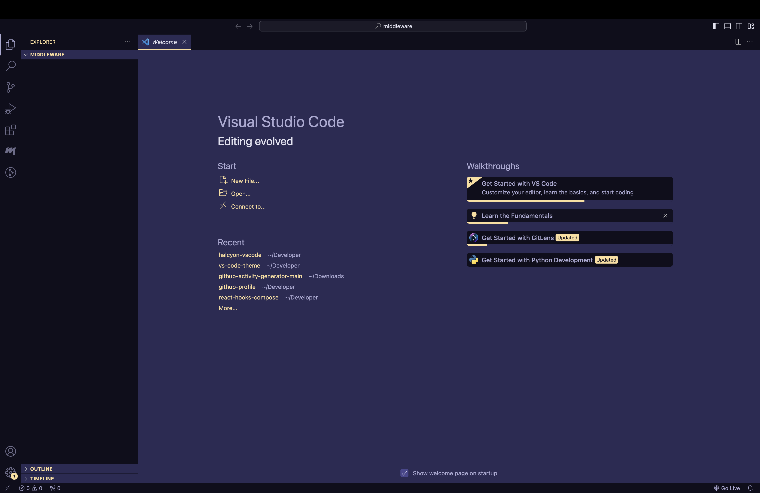

1. **Node.js Installation Proof:**

*Screenshot showing the output of node -v and npm -v*

